Supplementary Materials

Design and structural bioinformatics analysis of polypeptide antigens useful for the SRLV serodiagnosis

Supplementary Fig. 1. Optimal superposition of the homology models of the p25-variants 1 (green), 2 (cyan) and 3 (magenta) on their templates 1EIA (yellow) and N-terminal domain chain A of 3GV2 (salmon) with their respective RMSD. As seen by the figure the N-terminal domain of 3GV2 (3GV2_N) aligns well with the other structures but its C-terminal domain (3GC2_C) is shifted. However, when 3GC2_C is aligned to the C-terminal domains of the other structures it also superimposes well, i.e. the conformation of the N- and C-terminal domains as rigid bodies are different in 3GC2 with respect to the other structures.

 | 1EIA |  | P25_1 |  | P25_2 |  | P25_3
Clash score | 29.1 |  | 0.29 |  | 0 |  | 0
Poor rotamers | 8 | 4.5% | 2 | 1.1% | 4 | 2.2% | 2 | 1.1%
Favoured rotamers | 166 | 93.3% | 183 | 96.3% | 175 | 95.6% | 184 | 96.8%
Ramachandran outliers | 7 | 3.4% | 3 | 1.4% | 1 | 0.5% | 3 | 1.4%
Ramachandran favoured | 178 | 86.8% | 209 | 95.9% | 211 | 95.9% | 210 | 96.3%
C_{β} deviations  > 0.25 Å | 0 | 0% | 1 | 0.5% | 0 | 0% | 0 | 0%
Bad bonds | 0/1678 | 0% | 2/1765 | 0.1% | 1/1764 | 0.1% | 2/1779 | 0.1%
Bad angles | 1/2276 | 0% | 2/2391 | 0.1% | 2/2386 | 0.1% | 2/2411 | 0.1%
Cis-prolines | 0/16 | 0% | 0/8 | 0% | 0/10 | 0% | 0/10 | 0.1%

Supplementary Table 1. MolProbity analysis of protein geometry of the templates and the structural homology models of the p25-variants 1, 2 and 3. 3GV2 could not be compared since it only contains coordinates for the C_{α}-trace.

Supplementary Fig. 2. The homology models of the p25-variants 1 (top), 2 (centre) and 3 (bottom) in cartoon with side chains in sticks coloured according to their chemical properties: positively charged (blue), negatively charged (red), polar (green) and hydrophobic (yellow) residues. The hydrophobic residues are mainly buried in the protein core while the charged residues and the major part of the polar residues are found in solvent-accessible positions.

Supplementary Fig. 3. The homology model of the p25-variants 1 in cartoon with side chains in sticks in rainbow colours according to their conservation from blue (most conserved) to red (least conserved). The sequences used in the multiple sequence alignment were selected with 95% redundancy from the 1460 sequences found in databases and mapped onto the p25-variant 1 homology model by using ConSurf. The hydrophobic core consists mainly of conserved residue while the solvent-accessible residues are more variable.

Supplementary Fig. 4. Optimal superposition of the homology models of TM_1 (green) and TM_2 (cyan) on their templates 1QCE (yellow) and 1JEK (magenta)with their respective RMSD.

Supplementary Table 2

 | 1QCE |  | 1JEK |  | TM_1 |  | TM_2 |  | TM_1_2ac |  | TM_1_2ab
Clash score | 0 |  | 7.39 |  | 0 |  | 0.2 |  | 0 |  | 0.78
Poor rotamers | 27 | 8.3% | 0 | 0% | 4 | 1.4 % | 11 | 3.9% | 5 | 2.4 % | 3 | 1.5 %
Favoured rotamers | 264 | 80.7% | 174 | 100% | 279 | 95.9 % | 259 | 90.9% | 198 | 96.6 % | 196 | 95.6 %
Ramachandran outliers | 3 | 0.8% | 0 | 0% | 10 | 3.1 % | 3 | 0.93% | 4 | 1.7 % | 3 | 1.3 %
Ramachandran favoured | 342 | 94.2% | 210 | 100% | 301 | 93.8 % | 296 | 92.2% | 218 | 93.2 % | 214 | 91.5 %
C_{β} deviations  > 0.25 Å | 0 | 0% | 0 | 0% | 0 | 0% | 0 | 0% | 0 | 0% | 0 | 0%
Bad bonds | 9/3114 | 0.3% | 0/1788 | 0% | 5/2796 | 0.2 % | 6/2769 | 0.2% | 4/1988 | 0.2 % | 3/1988 | 0.2 %
Bad angles | 21/4233 | 0.5% | 0/2412 | 0% | 6/3801 | 0.2 % | 10/3759 | 0.3% | 5/2701 | 0.2 % | 4/2701 | 0.2 %
Cis-prolines | 0/9 | 0% | 0 | 0% | 0/3 | 0% | 0/3 | 0% | 0/2 | 0% | 0/2 | 0%

Supplementary Table 2. MolProbity analysis of protein geometry of the templates and the structural homology models of TM_1, TM_2, TM_1_2ac and TM_1_2ab.

Supplementary Fig. 5. The homology models of TM_1 (top) and TM_2 (bottom) with chains B and C in light gray surface whereas chain A is in cartoon with side chains in sticks coloured according to their chemical properties: positively charged (blue), negatively charged (red), polar (green) and hydrophobic (yellow) residues. The intramolecular interactions between helices as well as the intramolecular interactions of the helix-loop-helix trimers consist mainly of hydrophobic residues that are buried while the charged residues and the major part of the polar residues are found in solvent-accessible positions.

Supplementary Fig. 6. The homology model of TM_1 with chains B and C in cyan surface whereas chain A is in cartoon with side chains in sticks in rainbow colours according to their conservation from blue (most conserved) to red (least conserved). The sequences used in the multiple sequence alignment were selected with 95% redundancy from the 482 sequences found in databases and mapped onto the TM_1 homology model by using ConSurf. The intramolecular interactions between helices as well as the intramolecular interactions of the helix-loop-helix trimers consist mainly of conserved residue while the solvent-accessible residues are more variable.

Supplementary Fig. 7. Homology model of "TM_1_2" dimers. Secondary structure of the TM_1_2ac dimer in rainbow colours from the N-terminus (blue) to the C-terminus (red) and TM_1_2ab in magenta. The linker between the TM_1 and TM_2 sequences in TM_1_2ac is connecting the yellow and green helices.

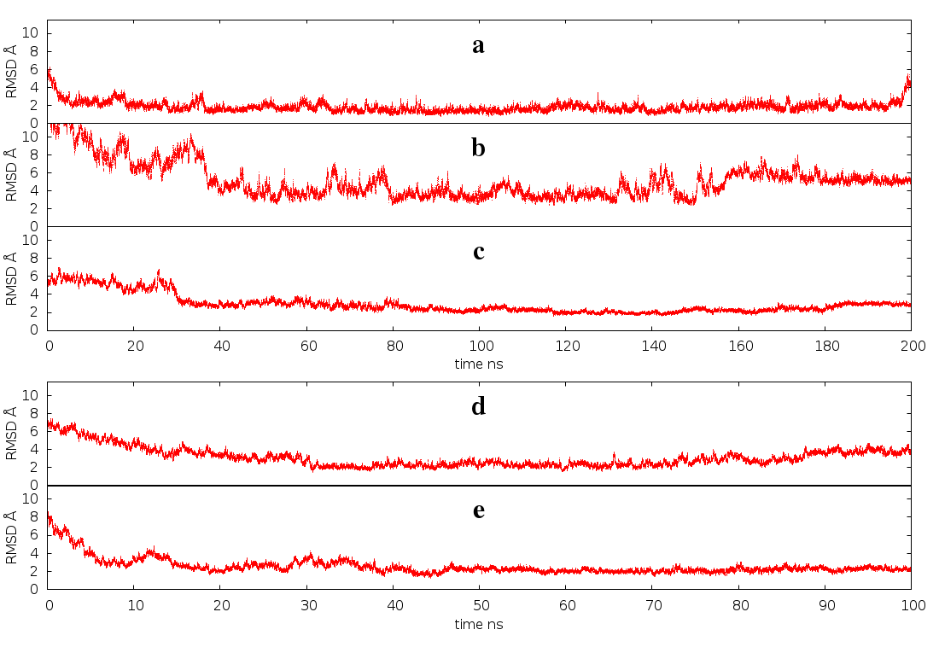

Supplementary Fig. 8. RMSD against the centroid (in Angstrom) as function of the time (ns) in the MD simulation of P25_1 (a) , TM_1 monomer (b), TM_1 trimer (c), TM_1_2ab (d) and TM_12_ac (e).

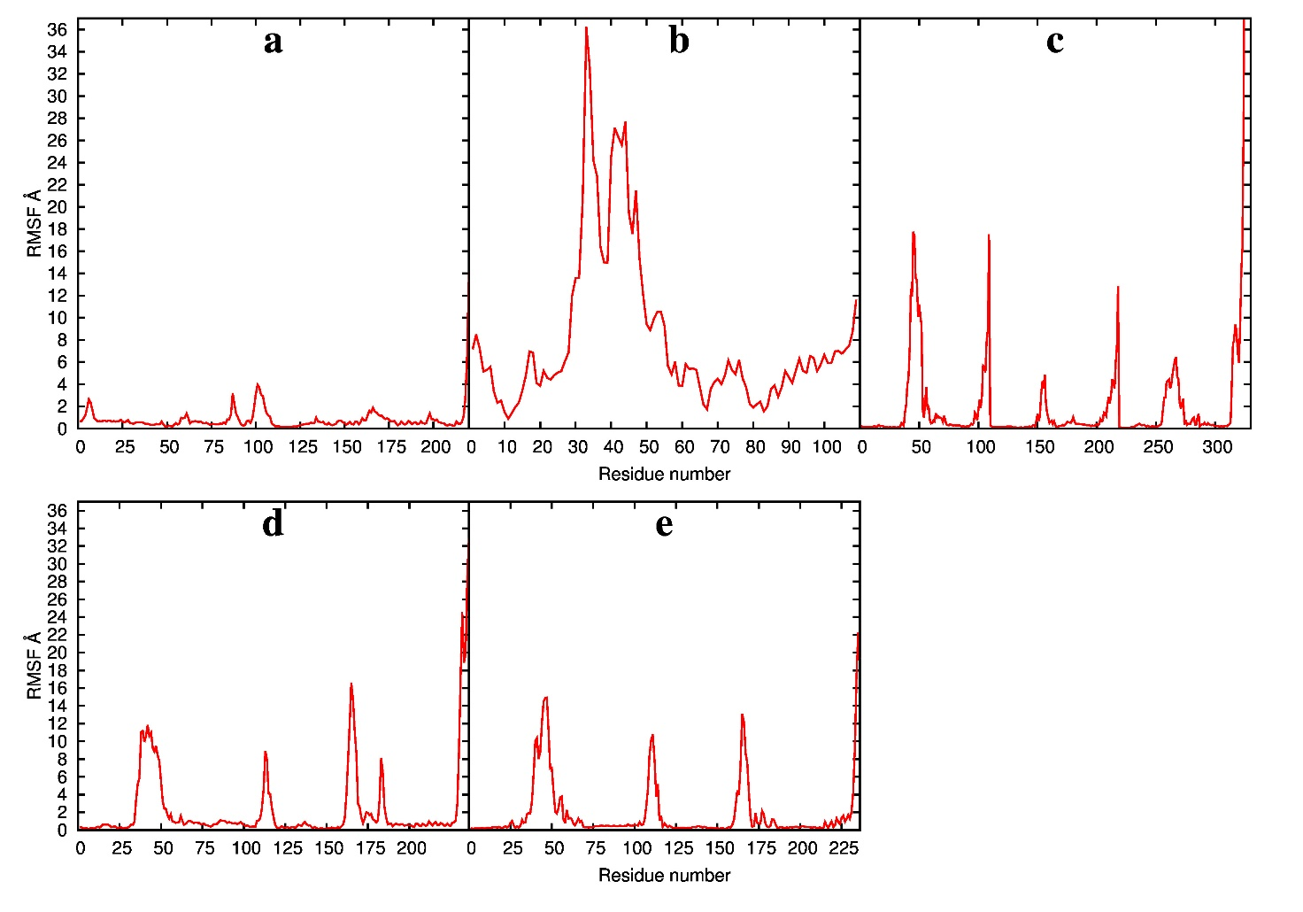
Supplementary Fig. 9. RMSF (in Angstrom) along the chain in the MD simulation of P25_1 (a), TM_1 monomer (b), TM_1 trimer (c), TM_1_2ab (d) and TM_1_2_ac (e).

Supplementary Fig. 10. Potential B-cell epitopes in the sequences and on the homology models of P25_1, P25_2 and P25_3 were predicted by using several programs for linear (ABCpred, BcePred, BepiPred, COBEpro and ElliPro_L) and discontinuous BEpro, DiscoTope, ElliPro_D, EPCES and SEPPA) epitopes. An "E" indicates where epitopes were predicted and the consensus predictions for the discontinuous epitopes (D_CONS) and all (A_CONS, i.e. both linear and discontinuous) epitopes were calculated at different intervals. Lower case letters indicate every 10 residues.

Supplementary Fig. 11. The consensus predictions for linear and discontinuous epitopes are displayed on the homology models of P25_1 (top), P25_2 (middle) and P25_3 (bottom) in blue with the consensus intervals ≥80% (red), 60-79% (orange) and 40-59% (yellow).

Supplementary Fig. 12. Potential B-cell epitopes in the sequences and on the homology models of TM_1 and TM_2 were predicted by using several programs for linear (ABCpred, BcePred, BepiPred, COBEpro and ElliPro_L) and discontinuous BEpro, DiscoTope, ElliPro_D, EPCES and SEPPA) epitopes. An "E" indicates where epitopes were predicted and the consensus predictions for the discontinuous epitopes (D_CONS) and all (A_CONS, i.e. both linear and discontinuous) epitopes were calculated at different intervals. Lower case letters indicate every 10 residues.

Supplementary Fig. 13. The consensus predictions for the discontinuous epitopes are displayed on the homology models of TM_1 (top) and TM_2 (bottom) in blue with the consensus intervals ≥80% (red), 60-79% (orange) and 40-59% (yellow).

Supplementary Fig. 14. CD spectrum of TM_1 (3 μM ) in phosphate buffer (A) and TFE (B) .CD spectrum of TM_2 (3 μM) in phosphate buffer (C) and TFE (D)

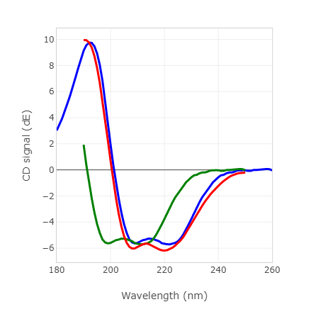
Supplementary Fig. 15. Superimposition of the TM_1 CD spectrum (red) in TFE with the average spectrum calculated from the MD simulation (bold blue). The envelope of the spectra corresponding to 100 sampled structures is in light blue. In green is reported (shifted) the calculated spectrum closest to the experimental.

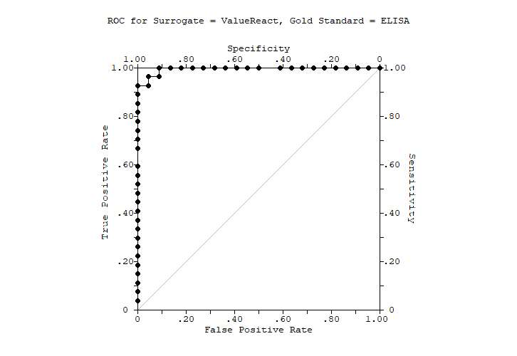

Supplementary Fig. 16. ROC graphic. Area under the non-parametric ROC = 0.9949. Standard Error of Area = 0.0052. 95% Confidence Limits of Area = (0.9847,1.0000)

